CSA1110 – OBJECT ORIENTED ANALYSIS & DESIGN

EXP -4 STOCK MAINTANENCE SYSTEM

UML DIAGRAM

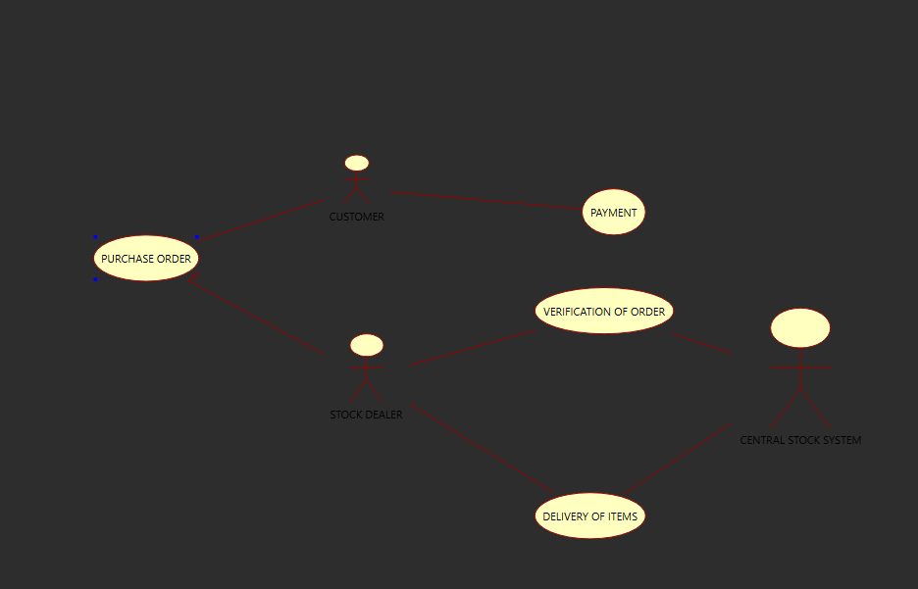

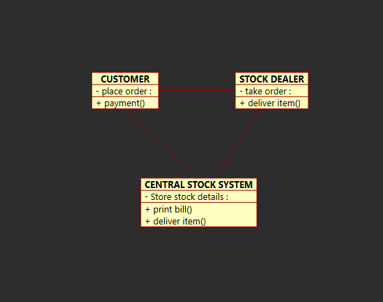

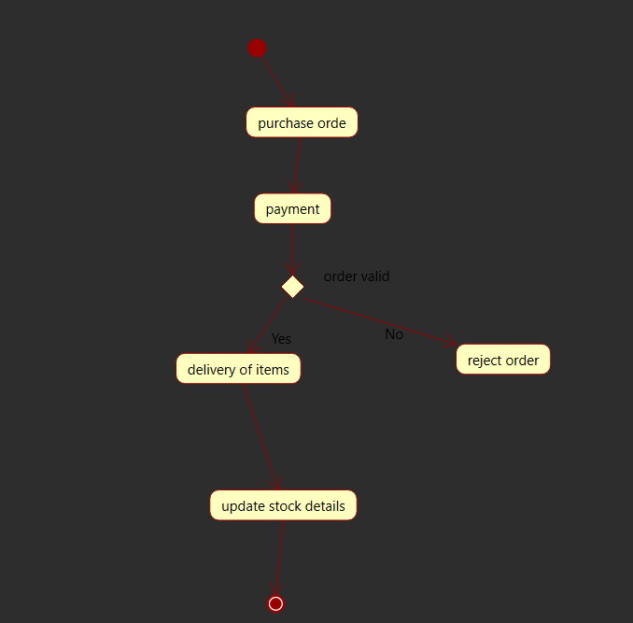

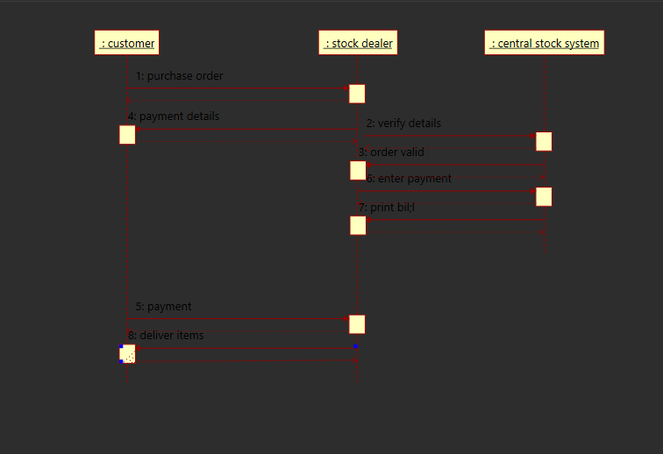

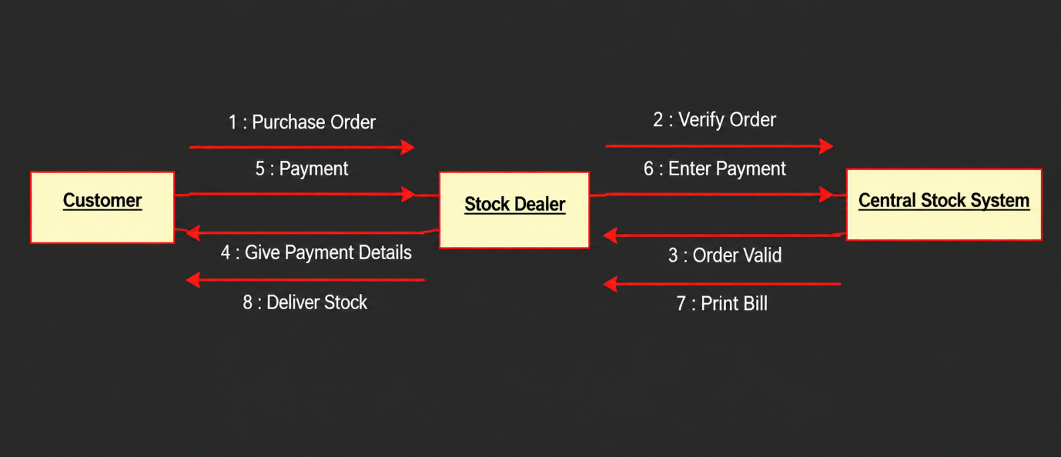

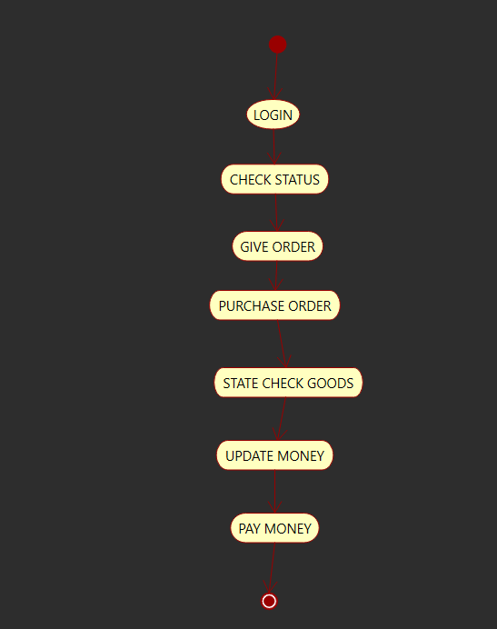

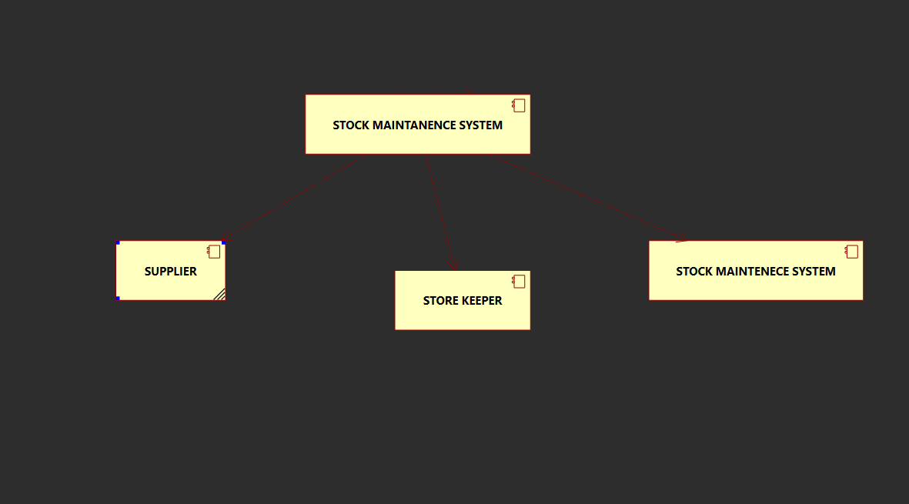

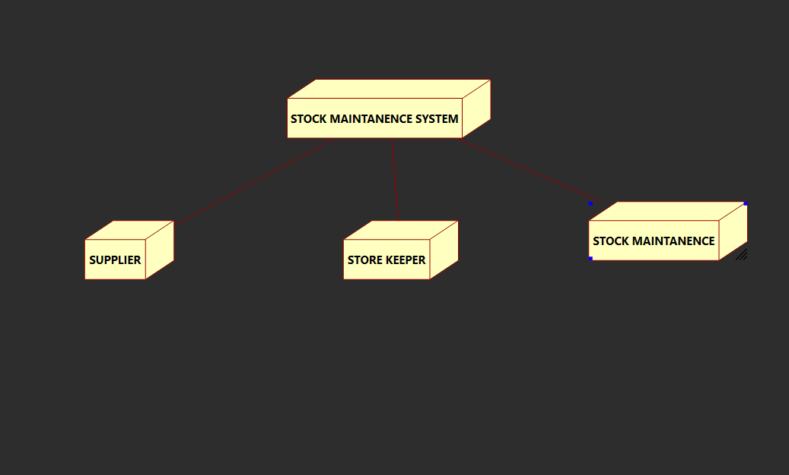

PROGRAM CODE

import tkinter as tk
from tkinter import messagebox

# ---------------- FORM 1: HOME ----------------
def open_home():
root = tk.Tk()
root.title("Stock Maintenance System - Home")
root.geometry("500x350")
root.configure(bg="#eaf2f8")

tk.Label(
root, text="STOCK MAINTENANCE SYSTEM",
font=("Arial", 17, "bold"), bg="#eaf2f8",
fg="#154360"
).pack(pady=25)

tk.Label(
root, text="Manage customer orders, payments and stock",
font=("Arial", 10), bg="#eaf2f8"
).pack(pady=5)

tk.Button(
root, text="Form 2: Customer Order",
width=30, command=open_customer_form
).pack(pady=8)

tk.Button(
root, text="Form 3: Verification & Payment",
width=30, command=open_payment_form
).pack(pady=8)

tk.Button(
root, text="Form 4: Delivery & Stock Update",
width=30, command=open_delivery_form
).pack(pady=8)

tk.Button(
root, text="Exit", width=15, command=root.destroy
).pack(pady=15)

root.mainloop()

# ---------------- FORM 2: CUSTOMER ORDER ----------------
def open_customer_form():
win = tk.Toplevel()
win.title("Form 2 - Customer Order")
win.geometry("450x400")
win.configure(bg="#fdf2e9")

tk.Label(
win, text="CUSTOMER ORDER FORM",
font=("Arial", 16, "bold"), bg="#fdf2e9"
).pack(pady=15)

tk.Label(win, text="Customer Name", bg="#fdf2e9").pack()
name = tk.Entry(win, width=35)
name.pack(pady=5)

tk.Label(win, text="Item Name", bg="#fdf2e9").pack()
item = tk.Entry(win, width=35)
item.pack(pady=5)

tk.Label(win, text="Quantity", bg="#fdf2e9").pack()
quantity = tk.Entry(win, width=35)
quantity.pack(pady=5)

def place_order():
if not name.get().strip() or not item.get().strip():
messagebox.showwarning("Missing Data", "Enter customer and item names.")
return

try:
qty = int(quantity.get())
if qty <= 0:
raise ValueError
except ValueError:
messagebox.showwarning("Invalid Quantity", "Enter a quantity greater than zero.")
return

order_data["customer"] = name.get().strip()
order_data["item"] = item.get().strip()
order_data["quantity"] = qty
order_data["verified"] = False
order_data["paid"] = False
order_data["delivered"] = False

messagebox.showinfo("Order", "Customer order placed successfully.")

tk.Button(
win, text="Place Order", width=20, command=place_order
).pack(pady=15)

# ---------------- FORM 3: VERIFICATION & PAYMENT ----------------
def open_payment_form():
win = tk.Toplevel()
win.title("Form 3 - Verification and Payment")
win.geometry("450x350")
win.configure(bg="#e8f8f5")

tk.Label(
win, text="ORDER VERIFICATION & PAYMENT",
font=("Arial", 14, "bold"), bg="#e8f8f5"
).pack(pady=20)

status = tk.Label(win, text="Place an order first.", bg="#e8f8f5")
status.pack(pady=10)

def verify_order():
if not order_data["customer"]:
messagebox.showwarning("No Order", "Place an order in Form 2 first.")
return

order_data["verified"] = True
status.config(text="Order verified successfully.")
messagebox.showinfo("Verification", "Order verified successfully.")

def make_payment():
if not order_data["verified"]:
messagebox.showwarning("Verification Required", "Verify the order first.")
return

order_data["paid"] = True
status.config(text="Payment recorded successfully.")
messagebox.showinfo("Payment", "Payment completed successfully.")

tk.Button(
win, text="Verify Order", width=22, command=verify_order
).pack(pady=8)

tk.Button(
win, text="Process Payment", width=22, command=make_payment
).pack(pady=8)

# ---------------- FORM 4: DELIVERY & STOCK UPDATE ----------------
def open_delivery_form():
win = tk.Toplevel()
win.title("Form 4 - Delivery and Stock Update")
win.geometry("450x350")
win.configure(bg="#f4ecf7")

tk.Label(
win, text="DELIVERY & STOCK UPDATE",
font=("Arial", 16, "bold"), bg="#f4ecf7"
).pack(pady=20)

status = tk.Label(win, text="Waiting for a verified and paid order.",
bg="#f4ecf7", wraplength=350)
status.pack(pady=15)

def deliver_stock():
if not order_data["verified"] or not order_data["paid"]:
messagebox.showwarning(
"Cannot Deliver",
"Verify the order and complete payment first."
)
return

order_data["delivered"] = True
status.config(
text=f"Delivered {order_data['quantity']} x "
f"{order_data['item']} to {order_data['customer']}."
)
messagebox.showinfo(
"Delivery",
"Items delivered and stock update recorded."
)

tk.Button(
win, text="Deliver Items & Update Stock",
width=28, command=deliver_stock
).pack(pady=10)

tk.Button(
win, text="View Order Summary",
width=22, command=lambda: messagebox.showinfo(
"Order Summary",
f"Customer: {order_data['customer'] or 'N/A'}\n"
f"Item: {order_data['item'] or 'N/A'}\n"
f"Quantity: {order_data['quantity'] or 'N/A'}\n"
f"Verified: {order_data['verified']}\n"
f"Paid: {order_data['paid']}\n"
f"Delivered: {order_data['delivered']}"
)
).pack(pady=8)

# Shared order information for all four windows
order_data = {
"customer": "",
"item": "",
"quantity": 0,
"verified": False,
"paid": False,
"delivered": False
}

# Start the application
open_home()

